TEST:

1. create a ssrs report that show drill down

Ans:

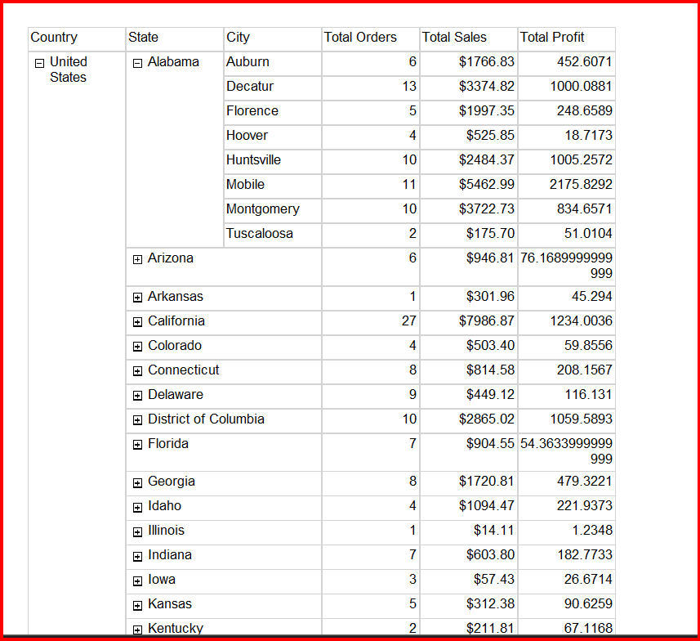

1. create a SSRS report that show conditional formatting

Ans:

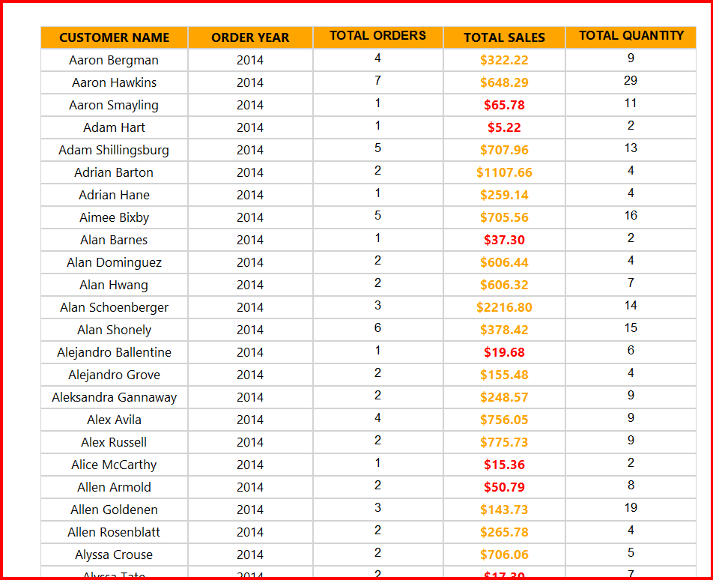

1. create a SSRS report that show sub report

Ans:

1. create a SSRS report that show difference between table vs matrix

Ans:

